Student ID:103475009

Name:Maxwell Barrah

# Setup Screenshot

# Task 2 Screenshot

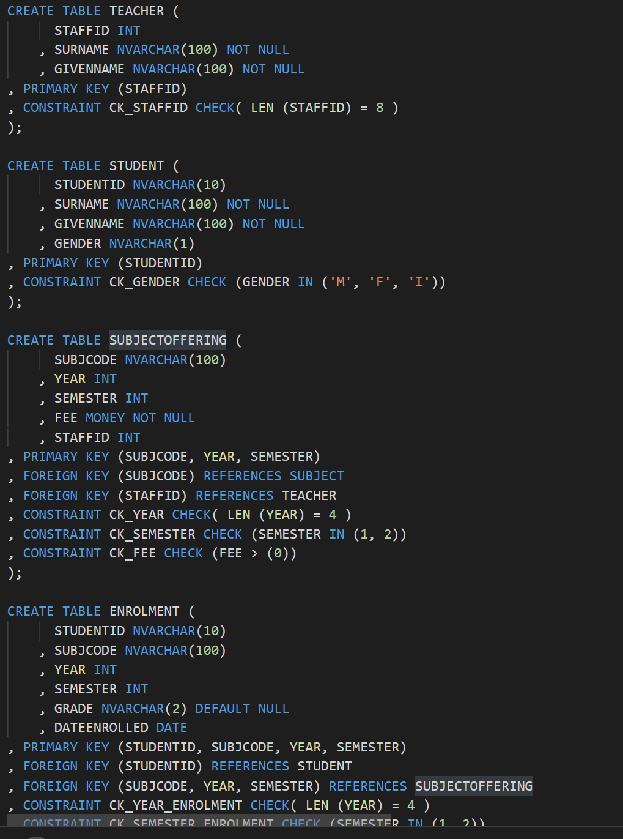

# Task 3 Screenshot

